Test Project

Startech's Days 2022

Day 3: Flick Colors

Skill : Web Development

Proof made by : Pierre Charlier

Employer : Forem - Cepegra

# Application Development

Famous Flash game. The goal of this game is to change the colour of the squares in order to finish with all squares of the same colour in less than 10 clicks. When you click on a square, the first square on the top left and all adjacent squares with the same colour take the colour of the clicked square.

## Description of the project and the tasks to be carried out

Integrate the wireframes provided and p ropose a basic design. Propose a display of the result (win or lose).

Display a form offering to choose the number of boxes (6x6 to 8x8) and the number of colours (4 to 8).

Display the grid according to the choices provided by the user.

Display the number of clicks out of 10 (0/10 at the beginning).

When a colour is clicked, assign that colour to the top left box and all adjacent boxes of the same colour. Increment the click counter.

The game stops when all the squares are of the same colour and/or when the click counter is equal to 10.

### Wireframes

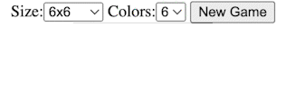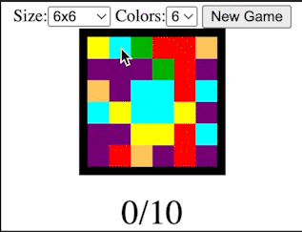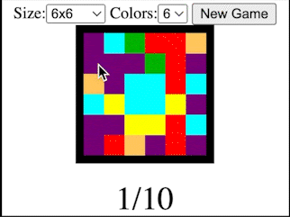

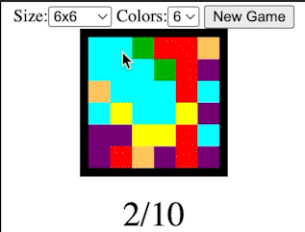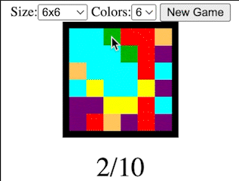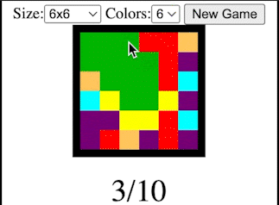

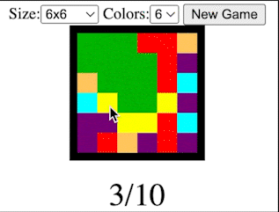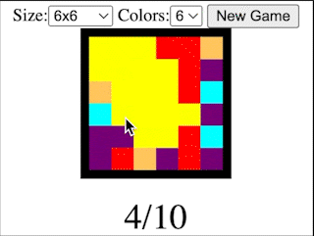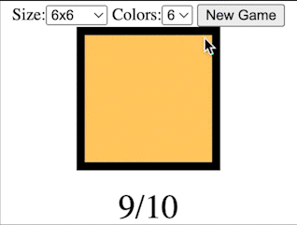

### To be changed

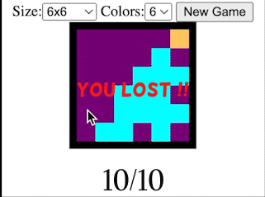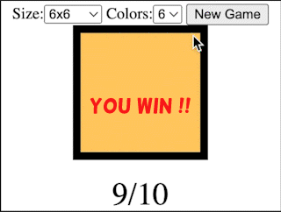

## Instructions for COMPETITORS

You can choose between :

* Development in Vanilla or using a framework (Vue, React or Angular).

Duration: 3.5 hours.

## material to be taken by the cOMPETITORS

Personal keyboard or mouse allowed.

## PROHIBITED MATERIAL DURING THE COMPETITION

It is forbidden to use anything that might disturb your work: mobile phones, radios, MP3s.

No digital storage solution

## rating procedure

**Distribution of points**

|  |  |
| --- | --- |
| Work organisation and self-management | 4 |
| Graphic proposal | 3 |
| Development of client functionalities | 12 |

## SAFETY INSTRUCTIONS

No

## ANNEXES :

* Technical document

## Can this document, including annexes, BE sent to competitors before the event?

## NO

## 